DEPARTMENT OF HUMAN RESOURCE MANAGEMENT
INDIAN INSTITUTE OF ENGINEERING SCIENCE AND TECHNOLOGY, SHIBPUR

NOTICE

No. ____________________ Date: 24/01/2022

Attention: All the students of IIESTS
Subject: NEC & Mitsubishi Corporation Hackathon in India

This is to notify to all the students of IIESTS who are interested in participating in the NEC & Mitsubishi Corporation Hackathon in India, should register for this event using the link given below. The event details are as given below.
The hackathon theme is "Automobile". With this theme, the organizer would like to find innovative ideas and solutions on the theme of "New Digital Transformation through Automobiles in India".
This hackathon is open for everyone, from 1st year to final year students, anyone can register.
The total prize money is 2.5 Lakhs INR, and if participants are selected for the hackathon phase, they will get an official certificate too.
Prize Money - 1st prize: INR 120,000, 2nd prize: INR 80,000, 3rd prize: INR 50,000
Register & apply from here:
https://www.hackerearth.com/challenges/hackathon/india-automobile-hackathon-by-nec-and-mitsubishi-corporation-india/
Application deadline - By 30th January 2022 (Sun)
Hackathon Date - 19th Feb (Sat) & 27th Feb (Sun)
{1 week mentoring would be provided for selected teams)
Venue – Online
Register & Application from:
https://www.hackerearth.com/challenges/hackathon/india-automobile-hackathon-by-nec-and-mitsubishi-corporation-india/
Telegram group to share update info etc, https://t.me/joinchat/Hz0RWfuqtwR6RqT5
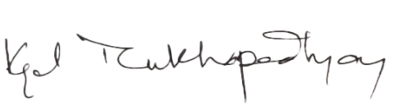
(Kajal Mukhopadhyay)
Human Resource Management Department

